 | 26.19 Editors - Properties Editor – Strip Tab
Table of content
Strip Tab 6
Strip tab header 6
Breadcrumb 6
Pin 6
Type Icon 6
Name 6
Color 6
Mute 7
Compositing Panel 7
Blend 7
Opacity 7
Transform Panel 7
Filter 7
Auto 7
Nearest 7
Bilinear 8
Cubic Mitchell 8
Cubic B-Spline 8
Box 8
Position X 8
Y 8
Scale X 8
Y 8
Rotation 8
Origin 8
Mirror 8
Crop Panel 8
Left, Right, Top, Bottom 9
Video Panel 9
Strobe 9
Reverse Frames 9
Color Panel 9
Saturation 9
Multiply 9
Multiply Alpha 9
Convert to Float 9
Sound Panel 9
Volume 10
Mono 10
Pan 10
Time Panel 10
Lock 10
Show Retiming Keys 10
Channel 10
Start 10
Duration 10
End 10
Strip Offset Start 10
End 11
Hold Offset Start 11
End 11
Current Frame 11
Scene Panel 11
Scene Property 11
Scene Browser 11
Scene edit box 11
Add 11
New 11
Copy Settings 11
Linked Copy 12
Full Copy 12
Remove 12
Input 12
Input Type Camera 12
Volume 12
Camera 12
Show Annotation 12
Transparent 12
Input type Sequencer 12
Volume 12
Mask Panel 12
Mask Property 12
Mask Browser 13
Mask edit box 13
Fake User 13
Remove 13
Effect Strip Panel 13
Effect strip type Color Mix 13
Input 1 13
Input 2 13
Swap Strips 13
Blend Mode 13
Blend Factor 13
Effect strip type Text 14
Text 14
Wrap Width 14
Style sub panel 14
Font property 14
Font browser 14
Open 14
Font Edit Box 14
Fake User 14
Open Font 14
Remove 14
Bold 15
Italic 15
Size 15
Color 15
Shadow 15
Shadow color 15
Angle 15
Offset 15
Blur 15
Outline 15
Color 15
Width 15
Box 15
Box Color 15
Margin 15
Layout sub panel 16
Location X/Y 16
Alignment 16
Anchor X/Y 16
Effect strip type Gaussian Blur 16
Input 1 16
Size X 16
Y 16
Effect strip type Multicam 16
Source Channel 16
Cut to 16
Effect strip type Speed Control 16
Input 16
Speed Control 17
Stretch 17
Multiply 17
Multiply factor 17
Frame Number 17
Frame number 17
Length 17
Interpolation 17
Effect strip type Color 17
Color Picker 17
Effect strip type Transform 17
Input 1 17
Interpolation 17
Translation Unit 17
Position X 18
Y 18
Uniform scale 18
Scale X 18
Y 18
Rotation 18
Effect strip type Glow 18
Input 1 18
Threshold 18
Clamp 18
Boost Factor 18
Blur Distance 18
Quality 18
Only Boost 18
Effect strip type Wipe 19
Input 1 19
Input 2 19
Swap Inputs 19
Transition type 19
Direction 19
Blur width 19
Angle 19
Default Fade 19
Effect strip type Alpha over Drop 19
Input 1 19
Input 2 19
Swap Inputs 19
Default Fade 19
Effect strip type Multiply 20
Input 1 20
Input 2 20
Swap Inputs 20
Effect strip type Gamma Cross 20
Input 1 20
Input 2 20
Swap Inputs 20
Default Fade 20
Effect strip type Alpha Under 20
Input 1 20
Input 2 20
Swap Inputs 20
Default Fade 20
Effect strip type Alpha Over 21
Input 1 21
Input 2 21
Swap Inputs 21
Default Fade 21
Effect strip type Subtract 21
Input 1 21
Input 2 21
Swap Inputs 21
Effect strip type Add 21
Input 1 21
Input 2 21
Swap Inputs 21
Effect strip type Crossfade 21
Input 1 21
Input 2 22
Swap Inputs 22
Default Fade 22
Source Panel 22
File 22
Browse 22
Color Space 22
Stream Index 22
Deinterlace 22
Info Box 22
Custom Properties Panel 23
Add 23
Edit 23
Remove 23

Strip Tab

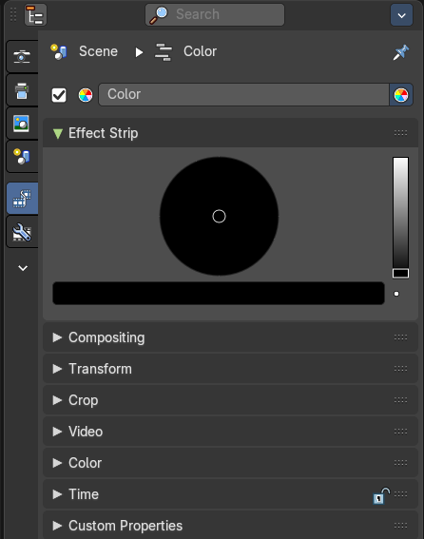
The strip tab contains all the strip type related settings. For the different strip types see the Add menu.
Some panels have the same content for all strip types. Some not. Some strip types have their own panels.
Note: Like in the 3D View, this tab is also accessible from the Sequencer sidebar.

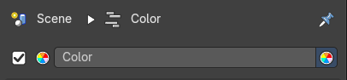
Strip tab header
In the strip tab header you will see an icon for the current strip type. The name of the strip. And a checkbox to set this strip active.
The strip can be renamed by double clicking left into the edit box.

Breadcrumb
This shows what scene and what strip the active selected strip tab properties are showing.

Pin
This pins the active selected strip so that when you select another strip, the properties won’t change and remembers the pinned strip properties.

Type Icon
This indicates what kind of strip is selected

Name
The name of the strip.

Color
The color of the strip in the sequencer timeline.

Mute
Enables/Disables the strip.

Compositing Panel
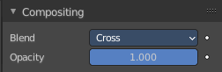
Available for Movie, Image, Adjustment and Meta strips.

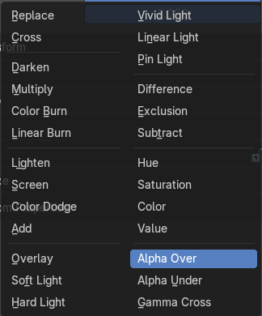
Blend
The blend method to control how the strip combines with other strips.

Opacity
How much the strip color affects other strips.

Transform Panel
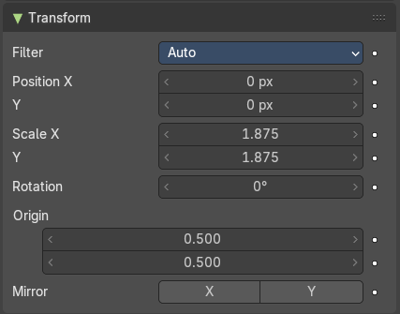

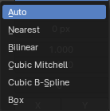
Filter
Filter type to use for transformations.

Auto
Automatically choose filter based on scaling factor.

Nearest
Use nearest sample.

Bilinear
Interpolate between 2x2 Samples

Cubic Mitchell
Cubic Mitchell filter on 4x4 Samples.

Cubic B-Spline
Cubic B-Spline Filter on 4x4 Samples. Blurry, but not ringing.

Box
Averages source image samples that fall under destination pixel.

Position X
The X offset.

Y
The Y offset.

Scale X
The X scale.

Y
The Y scale.

Rotation
The rotation around the image center.

Origin
Origin of image for transformation.

Mirror
Flip on the X and/or Y axis.

Crop Panel

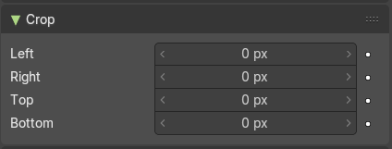
Left, Right, Top, Bottom
Crop the frame.

Video Panel

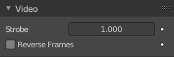
Strobe
Don't display every frame, but just every nth frame.

Reverse Frames
Reverse the frame order.

Color Panel

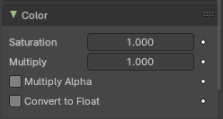
Saturation
The intensity of the input color.

Multiply
Multiply colors by this factor.

Multiply Alpha
Multiply Alpha along with color channels.

Convert to Float
Convert input to float data.

Sound Panel
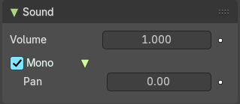
This panel shows with an audio clip selected.

Volume
The volume of the audio clip.

Mono
Set the audio clip to mono.

Pan
When mono, the pan of the audio clip.

Time Panel

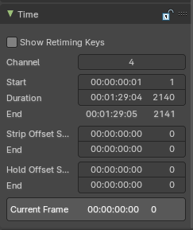
Time related settings.

Lock
Lock strip so that it cannot be transformed.

Show Retiming Keys
This toggles the overlay and retiming state of a Movie or Image Sequence strip. For more information, refer to chapter Editors - Video Sequence Editor - Header - Strip Menu retiming section.
Note: To retime a strip, select a Movie or Image Sequence strip.

Channel
The channel of the strip.

Start
The start frame of the strip.

Duration
The duration of the strip.

End
The end frame of the strip.

Strip Offset Start
The strip offset start. This offsets the beginning of the strip in the timeline.

End
The strip offset end. This offsets the end of the strip in the timeline.

Hold Offset Start
Animation start offset (trim start)

End
Animation end offset (trim end)

Current Frame
Info box that displays the position of the frame cursor at the current frame.

Scene Panel
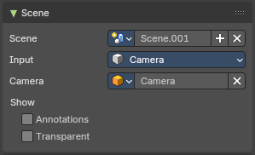
This panel just shows with strip type scene.

Scene Property

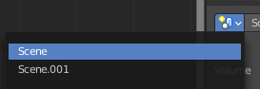
Scene Browser
A scene browser that contains the available scenes in the file.

Scene edit box
The name of the scene. It can be renamed by double clicking into the edit box.

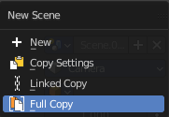
Add
Add a new scene. This button calls a menu where you can choose with what method you want to create the new scene.

New
Adds a new empty scene.

Copy Settings
Adds a new empty scene. And copies the settings from the current scene.

Linked Copy
Link in the collections from the current scene. (Shadow Copy)

Full Copy
Make a full copy of the current scene.

Remove
Remove the scene as the active one. Note that the scene is still available in the scene browser.

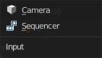
Input
Type of input to use. The camera of the scene. Or a file from the sequencer in this scene.

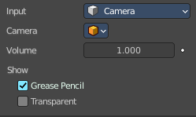
Input Type Camera

Volume
The audio volume.

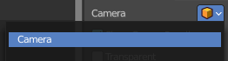
Camera
Which camera of the scene to use.

Show Annotation
Show grease pencil strokes in workbench previews.

Transparent
Use a transparent background.

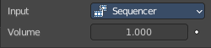
Input type Sequencer

Volume
The audio volume.

Mask Panel

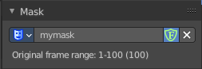
This panel just shows with strip type Mask.

Mask Property

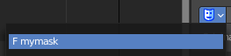
Mask Browser
A mask browser that contains the available masks in the file.

Mask edit box
The name of the scene. It can be renamed by double clicking into the edit box.

Fake User
Assign a fake user to this mask. Fake users is a odd concept to keep data in the scene even if it has no user somewhere. The fake user is then a dummy user so that the object is not deleted when saving the scene.

Remove
Remove the scene as the active one. Note that the scene is still available in the scene browser.

Effect Strip Panel

Settings for the single effect strip types.

The content differs, dependant of the chosen type.

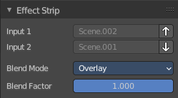
Effect strip type Color Mix

Input 1
The first strip.

Input 2
The second strip.

Swap Strips
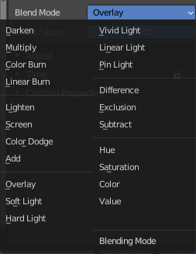
Swap the strips.

Blend Mode
The color blend mode to use.

Blend Factor
The blend factor. 1.000 means 100%.

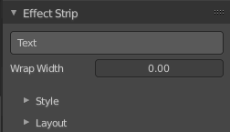
Effect strip type Text

Text
The text to displayed.

Wrap Width
World wrap width as factor. Zero disables the wrap.

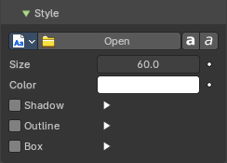
Style sub panel

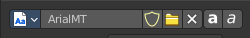
Font property
When no font is loaded then the internal font is used.

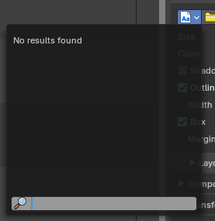
Font browser
The list of loaded fonts. This list is empty by default. It displays the fonts that you load.

Open
Load a font.

Font Edit Box
Display the current active font. You can rename the font by double clicking in the edit box.

Fake User
Assign a fake user to this font. Fake users is an odd concept to keep data in the scene even if it has no user somewhere. The fake user is then a dummy user so that the object is not deleted when saving the scene.

Open Font
Load a font.

Remove
Remove the selected font as the active one. Note that the font is still in the list then.

Bold
Display the font bold.

Italic
Display the font italic.

Size
Size of the text.

Color
The text color.

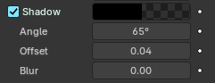
Shadow
Creates a shadow of the specified color under the text.

Shadow color
The color of the shadow. Clicking at the color field opens a color dialog.

Angle
The shadow angle. In which direction the shadow shall point.

Offset
Add an offset to the shadow in pixels

Blur
Blur the shadow by a pixel amount.

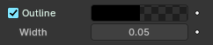
Outline

Color
The outline color.

Width
The outline width.

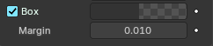
Box
Display colored box behind text.

Box Color
The color of the box.

Margin
The margin of the box. Based at the image width.

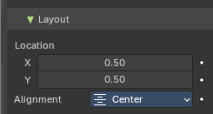
Layout sub panel

Location X/Y
Positions the text on the X, Y axis.

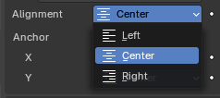
Alignment
The horizontal X alignment of the text. Can be Left, Center or Right

Anchor X/Y
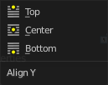
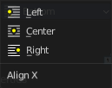
Horizontal (X) or vertical (Y) anchor point of the text relative to the location.

Effect strip type Gaussian Blur

Input 1
The strip to blur. This strip cannot be changed. You need to apply the effect with the correct strip selected.

Size X
The size of the blur along X axis.

Y
The size of the blur along Y axis.

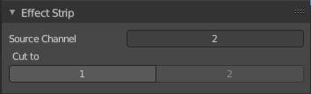
Effect strip type Multicam

Source Channel
The channel which the Multicam Selector gets its input from.

Cut to
Cuts the Multicam strip at the current frame and changes the Source Channel automatically to the selected channels.

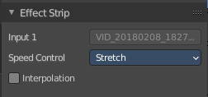
Effect strip type Speed Control

Input
The video where the speed control is applied to. This is read only.

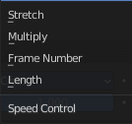
Speed Control

Stretch
Adjust input playback so that the input duration fits the strip length

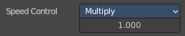
Multiply
Multiply with the speed factor.

Multiply factor
The speed factor.

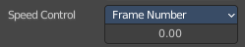
Frame Number
Frame Number of the Input strip.

Frame number
The frame number.

Length

Interpolation
Do crossfade blending between current and previous frame.

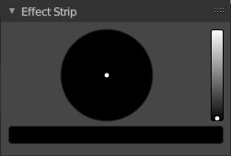
Effect strip type Color

Color Picker
Adjust the color of the color strip.

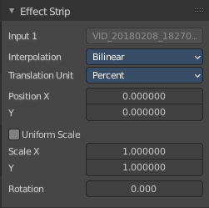
Effect strip type Transform

Input 1
The strip to transform. This strip cannot be changed. You need to apply the effect with the correct strip selected.

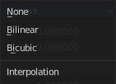
Interpolation
The interpolation type for the transform.

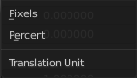
Translation Unit
The measure unit to use for the transform.

Position X
Amount to move the input in the X axis.

Y
Amount to move the input in the Y axis.

Uniform scale
Scale uniformly, preserve the aspect ratio.

Scale X
Amount to scale the input in the X axis.

Y
Amount to scale the input in the Y axis.

Rotation
Degrees to rotate the input.

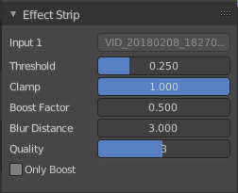
Effect strip type Glow

Input 1
The strip to use. This strip cannot be changed. You need to apply the effect with the correct strip selected.

Threshold
Minimum intensity to trigger a glow.

Clamp
The brightness limit of intensity.

Boost Factor
Brightness multiplier.

Blur Distance
The radius of the glow effect.

Quality
The accuracy of the blur effect.

Only Boost
Show the glow buffer only.

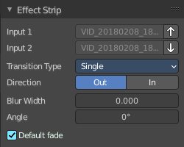
Effect strip type Wipe

Input 1
The first strip.

Input 2
The second strip.

Swap Inputs
Swap the two strips.

Transition type
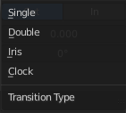
The wipe effect type.

Direction
The direction of the wipe.

Blur width
The width of the blur edge, relative to the image size.

Angle
The edge angle.

Default Fade
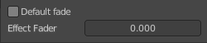
Use the builtin default effect time, which is as long as the fade clip. Or adjust the effect time.

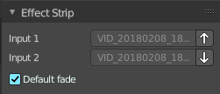
Effect strip type Alpha over Drop

Input 1
The first strip.

Input 2
The second strip.

Swap Inputs
Swap the two strips.

Default Fade
Use the builtin default effect time, which is as long as the fade clip. Or adjust the effect time.

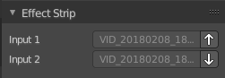
Effect strip type Multiply

Input 1
The first strip.

Input 2
The second strip.

Swap Inputs
Swap the two strips.

Effect strip type Gamma Cross

Input 1
The first strip.

Input 2
The second strip.

Swap Inputs
Swap the two strips.

Default Fade
Use the builtin default effect time, which is as long as the fade clip. Or adjust the effect time.

Effect strip type Alpha Under

Input 1
The first strip.

Input 2
The second strip.

Swap Inputs
Swap the two strips.

Default Fade
Use the builtin default effect time, which is as long as the fade clip. Or adjust the effect time.

Effect strip type Alpha Over

Input 1
The first strip.

Input 2
The second strip.

Swap Inputs
Swap the two strips.

Default Fade
Use the builtin default effect time, which is as long as the fade clip. Or adjust the effect time.

Effect strip type Subtract

Input 1
The first strip.

Input 2
The second strip.

Swap Inputs
Swap the two strips.

Effect strip type Add

Input 1
The first strip.

Input 2
The second strip.

Swap Inputs
Swap the two strips.

Effect strip type Crossfade

Input 1
The first strip.

Input 2
The second strip.

Swap Inputs
Swap the two strips.

Default Fade
Use the builtin default effect time, which is as long as the fade clip. Or adjust the effect time.

Source Panel

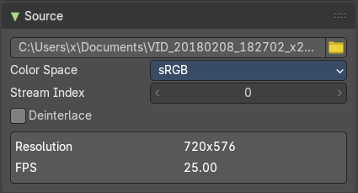
The source path and settings for a loaded video clip.

File
The source file.

Browse
Browse for another file.

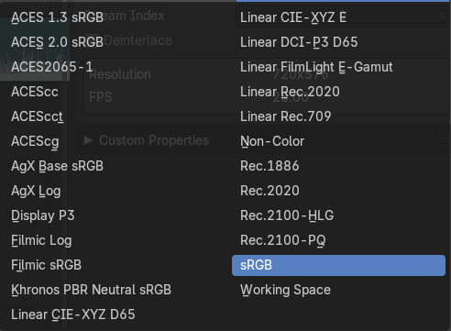
Color Space
Which color space to use for the loaded video clip.

Stream Index
For files with several movie streams, use the streamn with the given index.

Deinterlace
Remove fields from video movies.

Info Box
The resolution and frames per seconds of the video.

Custom Properties Panel


Here you can define custom properties that can be used for scripting.

Here you might also find custom properties from addons or scripts.

Add
Adds a new property.


Edit
Opens a panel where you can adjust the settings for the custom property.

Remove
Removes the property.

